Project Design Phase-II
Technology Stack (Architecture & Stack)

Date | 15 July 2026
Team ID | SWTID-2026-7507
Project Name | Darshan Ease
Maximum Marks | 4 Marks

Technical Architecture:
The Deliverable shall include the architectural diagram as below and the information as per the table1 & table 2
Darshan Ease – Temple Darshan Slot Booking & Queue Management: System Architecture
Reference: https://c4model.com/
Guidelines:
Include all the processes (As an application logic / Technology Block)
Provide infrastructural demarcation (Local / Cloud)
Indicate external interfaces (third party API’s etc.)
Indicate Data Storage components / services
Indicate interface to machine learning models (if applicable)
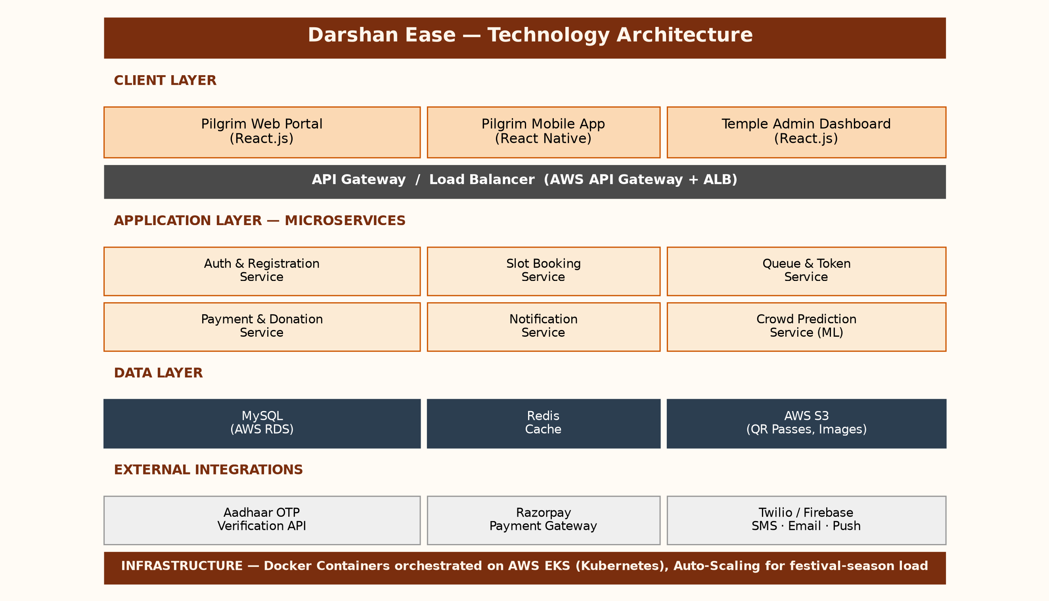

Table-1 : Components & Technologies:
S.No | Component | Description | Technology
1 | User Interface | Web portal and mobile app where pilgrims search temples, check live queue status, and book darshan slots | React.js (Web), React Native (Mobile), HTML5, CSS3
2 | Application Logic-1 (Slot Booking) | Handles darshan slot search, availability check, and booking logic | Node.js, Express.js
3 | Application Logic-2 (Queue Management) | Generates real-time tokens and manages live queue / crowd status updates | Node.js with Socket.io
4 | Application Logic-3 (Notifications) | Sends booking confirmations, queue-turn alerts, and reminders | Firebase Cloud Messaging, Twilio SMS/Email API
5 | Database | Stores pilgrim profiles, bookings, temple and slot data | MySQL
6 | Cloud Database | Managed relational database hosted on cloud | AWS RDS (MySQL)
7 | File Storage | Stores QR e-passes, temple images, and ID proof uploads | AWS S3
8 | External API-1 | Processes booking fees, donations, and prasad orders | Razorpay Payment Gateway API
9 | External API-2 | Verifies pilgrim identity during registration | Aadhaar-based OTP Verification API
10 | Machine Learning Model | Predicts crowd density and recommends optimal darshan slots | Crowd Prediction Model (Python, scikit-learn, time-series regression)
11 | Infrastructure (Server / Cloud) | Local Server Configuration: Docker containers for development  Cloud Server Configuration: AWS EC2 + Kubernetes (EKS) with auto-scaling for festival traffic | AWS Cloud, Kubernetes, Docker

Table-2: Application Characteristics:
S.No | Characteristics | Description | Technology
1 | Open-Source Frameworks | Open-source frameworks used to build the application | React.js, Node.js, Express.js, Redis
2 | Security Implementations | Access controls, encryption and identity checks implemented | JWT Authentication, HTTPS/TLS, AES-256 Encryption, Aadhaar OTP Verification, OWASP-compliant coding practices
3 | Scalable Architecture | Justification of scalability for handling festival-season traffic spikes | Microservices architecture containerized with Docker & orchestrated via Kubernetes (horizontal auto-scaling)
4 | Availability | Justification of high availability during peak pilgrim traffic | Multi-AZ deployment on AWS with Application Load Balancer and auto-scaling groups (99.9% uptime SLA)
5 | Performance | Design considerations for handling high concurrent booking requests | Redis caching for live queue data, CloudFront CDN for static assets, supports 10,000+ concurrent bookings

References:
https://c4model.com/
https://developer.ibm.com/patterns/online-order-processing-system-during-pandemic/
https://www.ibm.com/cloud/architecture
https://aws.amazon.com/architecture
https://medium.com/the-internal-startup/how-to-draw-useful-technical-architecture-diagrams-2d20c9fda90d

